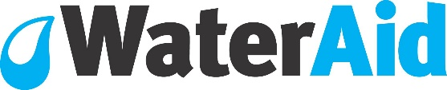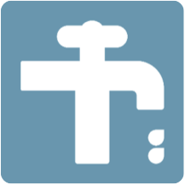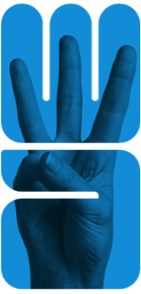

|  |  |
| --- | --- |
| C:\Users\conyenakie\Desktop\West African Map.png | **Visitors’ Welcome Pack: WaterAid Burkina Faso** |

|  |  |
| --- | --- |
| **Scope** | **Regional People Management Framework** |
| **Introduction** | The nature of WaterAid’s work necessitates working in volatile and sometimes violent environments. At times, this presents a threat to the security and well-being of our staff; an issue the organisation takes very seriously.  A Country Welcome Pack provides staff and visitors with a broad overview of the environment in which they are working or travelling to including essential security information good to know prior to visiting. It describes other factors that may not be included in a security plan such as currency information, cultural norms, local considerations, sensitivities, etc. |
| **Purpose** | The aim of this document is to inform short-term visitors of useful information that is important for their visit. Your welcome pack should:   * Provide a brief summary of the country including safety and security * Provide information on cultural practices * Provide information regarding airports and accommodation * Provide useful hints and tips regarding dress, communications, electricity, currency, eating out, getting around, health and climate. * Contain a short declaration to be signed by the visitor after the In-Country security briefing, whereby acknowledging that s/he is informed and understand the risks (informed consent). * To satisfy one of the requirements of WA’s duty of care.   Preferably, visitors should be able to access this or receive by mail prior to departing for your country as a pre-departure brief. |
| **First Published** | **January 2018** |
| **Last reviewed** | **July 2018** |

Welcome to Burkina Faso!

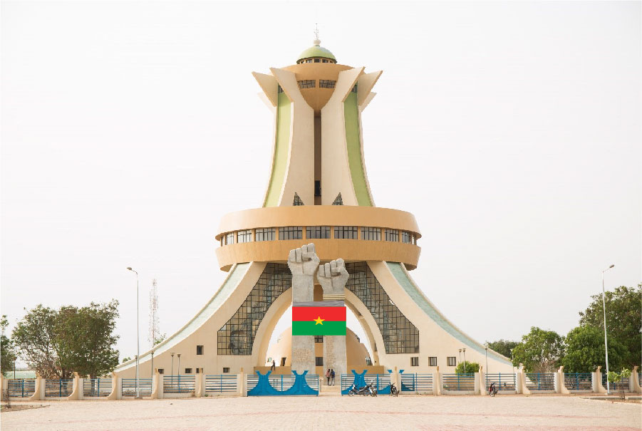

1. **Introduction**

WaterAid Burkina Faso is often hosting international visitors from member offices, donors and supporters. The aim of this Welcome Pack is to inform short-term visitors of useful information that is important for their visit. It’s updated regularly to reflect current security situation in Burkina, and will provide some useful information that visitors should know before starting their journey. The document serves as a pre-departure brief supplemented by a verbal security briefing upon arrival to Burkina.

**Security welcome Pack**

**Country Summary**

Located in West Africa, Burkina Faso is a landlocked country spread on 274 200 sk. and home to around 19 million people with 52% women, 19.5% young people from 15 to 24. The 2014 HDI was as low as 0.420 and life expectancy under 60 years. The population growth is 3.16%. Christians and Muslims live peacefully although traditional beliefs still exist. Burkina citizens are called Burkinabé and speak Mooré and Jula as the most common local languages although French the official language is also spoken by most average Burkinabé.

Communities generally welcome their visitors with a calabash/glass of water as a way of respect, trust and partnership. So remember not to turn down this cultural practice or stare at people in some cases.

Climate wise, Burkina has two main seasons: a raining season from May to September (27 to 37 degrees Celsius) and a dry one from October to April (30 to 41 degrees). So please, ensure you pack your suitcase accordingly**.**

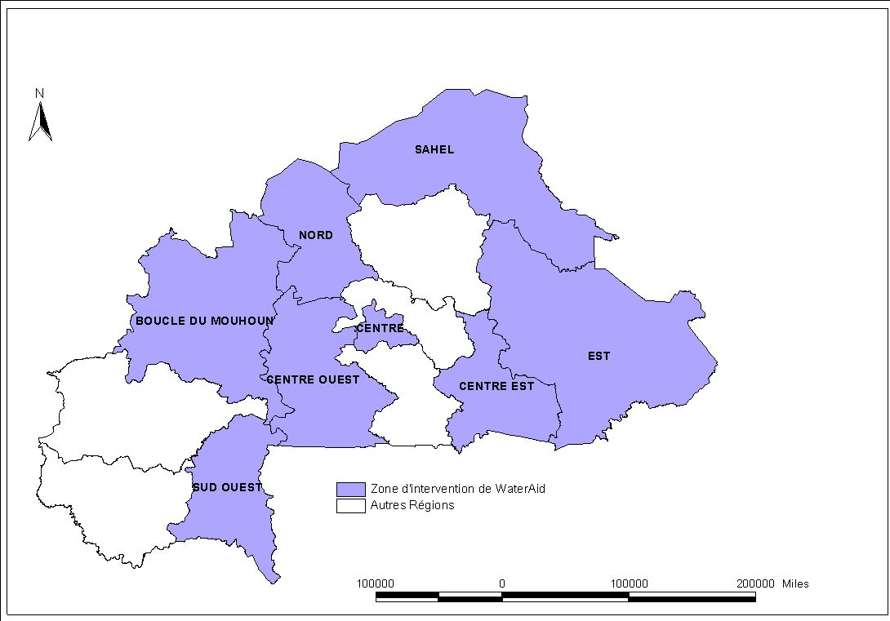

WaterAid Burkina has its office based in Ouagadougou, Ouaga 200 area and operates in forty (40) Local Governments in 08 regions out of 13 regions.

**Entry Requirements**

* **Passport &** **Visa: ECOWAS citizens require no entry visa to Burkina but nationals of other countries should apply for it**. Before your travel, please check your own visa requirements either with WABF or BF embassy in your country. Also, note that except some countries, visas can be issued on arrival at Ouagadougou airport. **WaterAid Burkina HR and admin Officer can support you in this regard. Bring along your updated yellow fever card and anti- malarial treatment**
* **Pick Up from and to airport** will be either by the hotel shuttle bus if arriving late or by our office driver holding a WaterAid placard at the arrival hall
* **Making Calls:** Burkina IDD code is 226 for international calls using different companies including a State owned (TELMOB) and two private (Orange and Telecel). On request, the CP team will make local SIM cards available to you on arrival with limited airtime.
* **Hotel Rooms:** Major Hotel rooms in Burkina are clean with air conditioner, hot & cold water, laundry service and TV sets with international channels such as CNN, BBC, France24, and TV5.
* **Accommodation: LAICO** Hôtel is in Ouaga 2000 area and at a walking distance of 20 minutes to WaterAid Office. For more information, visit their website: [http://www.laicohotels.com/fr/laico-ouaga-2000](http://www.laicohotels.com/fr/laico-ouaga-2000/)/

[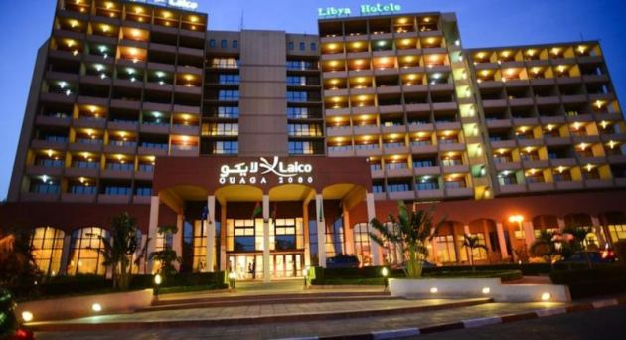](https://www.google.fr/url?sa=i&rct=j&q=&esrc=s&source=images&cd=&cad=rja&uact=8&ved=2ahUKEwiRlPO36sHbAhWjAcAKHYh2CJ0QjRx6BAgBEAU&url=https://www.rumbo.es/hoteles/burkina-faso/ouagadougou/hotel-sofitel-ouaga-2000&psig=AOvVaw1KbmV65oNl-kxWgayOsH2Z&ust=1528470281630424)

* **Currency and banking:** CFA (XOF) is the local currency with 1 Euro for 655,957 CFA. You may change your currency (Euro; Pounds and Dollars) at desks inside or outside the airport but avoid it with street individuals. International credit cards are accepted in most major hotels and in a few restaurants.
* **Health:** Before leaving your country, check with your doctor to get a contract with an insurance company to cover your medical and repatriation expenses.
* Always carry a first aid kit and anti-malaria drugs when traveling to country side
* Don’t buying food or drink sold by street vendors.
* Even during the raining season, the weather may still be hot such that it is recommended to drink as much as possible to avoid dehydration;

**Safety and Security:**

Both petty and violent crimes are of high concern. Petty street crime, such as pickpocketing and bag snatching occurs frequently. Incidents of armed robbery and sexual assault occur throughout the country, and banditry is frequently reported on main roads. There is a high risk of terrorism in Burkina. The risk stems from Islamist extremist organizations, including Al-Qaeda in the Islamic Maghreb, its affiliates, and more recently, a locally recruited Islamist militant group known as Ansaroul Islam. Road conditions are generally poor and may be impassable during the rainy season. The country has a history of disruptive civil unrest related to political developments in the country. The country has experienced instability since the ousting of Blaise Compaore and a military led coup but the situation is improving as highlighted by the peaceful general elections in 2015. The overall threat of conflict in Burkina Faso is low. Medical facilities are extremely limited in Burkina Faso, particularly outside the urban centres of Ouagadougou and Bobo-Dioulasso

* In any emergency case, liaise with WaterAid contacts in country including the CD or the SFP
* Don’t visit isolated places alone or unaccompanied
* Immediately report any suspicious activity the police or team members
* When in public, don’t display your cash, jewels and valuables
* Avoid large crowds including demonstrations.
* Bring a raincoat and appropriate clothing for rain

On arrival to office of hotel, a verbal security briefing will be delivered by SFP, Naba Kambou, +226 76.60.44.20 or +2226 71.02.29.43. [nabakambou@wateraid.org](mailto:nabakambou@wateraid.org)

**Nice to know**

* The local currency in use in Burkina is CFA (XOF). Current exchange rate indicates 655 957 XOF for 1 EURO.
* In the capital city and Bobo Dioulasso the second main town, international credit cards can be used in some bank ATM and few hotels and restaurants. Tipping waiters are not compulsory but recommended.
* Burkina uses the 2-prong type plugs and 220 Volts AC electricity system, i.e., universal adaptors may be needed for visitors from the UK and USA.
* In Ouaga and Bobo, internet is relatively good but unreliable in provinces. In both cities, the most common language is French as well as local languages including MOORE and JULA. Other local languages are spoken in different communities.
* Avoid taking pictures of public offices, army barracks, etc. In communities, this is possible but subject to their consent
* Sightseeing and recommended tourist attractions in Ouagadougou
* **‘Village** **Artisanal’** which is an Arts and Crafts Centre
* **Laongo**: artwork on stones, 15 km away from Ouagadougou.
* **Mogho Naba Palace** at the city centre where the MOSSI king performs on Fridays rituals when he threatens to leave his Kingdom
* “**Monument des Martyrs”** in Ouaga 2000: West Africa largest roundabout.

**Key contacts**

|  |  |  |
| --- | --- | --- |
| **WaterAid Burkina Faso**  OUAGA 2000, rue 15.661, Porte 98  11 BP 1211 CMS Ouagadougou 11,Burkina Faso.  Tel : +226 25 37 41 70 / 25 37 60 11 | | |
| **Full names and functions** | **Phone Numbers** | **Email details** |
| Halidou Koanda, Country Director | +226.70.21.73.00 | [halidoukoanda@wateraid.org](mailto:OumarouHamani@wateraid.org) |
| [Jean Pierre](mailto:azaraminoungou@wateraid.org) Djokpe, Head of People and OD | +226.70.51.58.69 | [jeanpierredjokpe@wateraid.org](mailto:azaraminoungou@wateraid.org) |
| Azara Minoungou, Head of Finance & IT | +226.70.28.48.37 | [azaraminoungou@wateraid.org](mailto:azaraminoungou@wateraid.org) |
| Leocadie Bouda Head of Programme | +226.70.26.14.34 | leocadiebouda[@wateraid.org](mailto:@wateraid.org) |
| Naba Kambou, Security Focal Point | +226.71.02.29.43 | [nabakambou@wateraid.org](mailto:nabakambou@wateraid.org) |
| Fire department | 18 |  |